Growth
What about GROWTH? What happens when a new school wants to join our MAT?
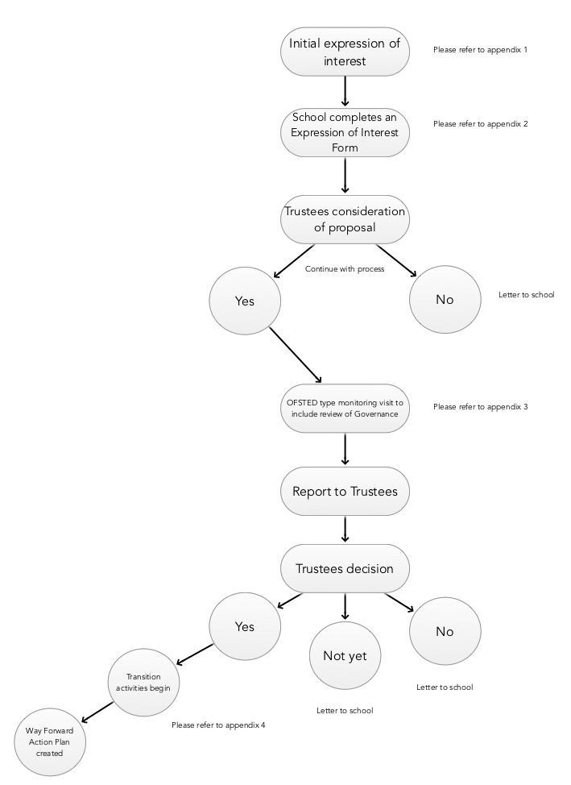
All schools are able to apply.

Methodology
and
Protocol

Due Diligence
Due Diligence activities

Appendix 1: Form A

The Rutland Learning Trust
Providing Outstanding Education for all pupils – today and tomorrow

The following questions are derived for your consideration. Your answers and discussions from these questions are intended to form the basis of subsequent conversations with representatives from The Rutland Learning Trust. Following these discussions the next steps are agreed.

- Have you spoken to the Diocese?
- What do you wish to achieve by this process?
- What will be the benefits for the pupils and the school, and what will be the implications for staff arising from the changes?
- What is the biggest challenge you are facing?
- How will these changes influence, impact and improve your levels of achievement and the quality of teaching and learning?
- What will the financial implications be?
- What powers, responsibilities and accountabilities will you have after the changes?
- Which organisations can you talk to, visit or ask in order to discuss their experiences of joining a MAT, the support they provided or received, and the resources available to them?
- Do you have confidence in the educational experience and track record of the RLT, and does it have the core competence to deliver successful school improvement and make a difference for you?
- What is it that drives the RLT? What is the ‘stamp in our stick of rock’ and does it match your values, vision, ethos and philosophy?
- Does your governing body have the necessary culture of challenge and eye for detail needed to take on these changes? If not, what options are available to you?
- What benefits will there be in terms of your reputation and the community?
- Any questions for the RLT?

Appendix 2: EXPRESSION OF INTEREST – FORM B

Contextual Statement to include:
Where are we now?
Key Priorities
Why do you want to join the MAT?
SWOT analysis

SEF Summary Document

Financial position statement including staff deployment

Governance structure

Recent monitoring activities undertaken: LA/Ofsted/Diocese/Other

