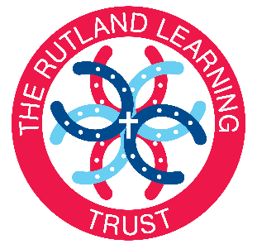

MINUTES OF THE AUDIT COMMITTEE
HELD ON 6 APRIL 2017 AT WHISSENDINE SCHOOL FROM 6PM
Present: David Evans, Nick Horrigan, Kristi Withers (part)
In attendance: Rob Gooding (Chief Executive Headteacher), Graham Kirby (CFO), Nicola Tyers (Clerk)
NO | ITEM | ACTION | TRUSTEE CHALLENGE & QUESTIONS
1. | Apologies for Absence. Apologies were received and accepted from Nicole Topham.
2. | Elect a Chair of the Committee. This election would take place at a future meeting when more Trustees are available.
3. | Terms of Reference. The Terms of Reference had already been ratified at the full Trustee meeting but would be need to be reviewed at a future meeting when more Audit trustees are in attendance.
4. | Responsible Officer Reports – Internal Audits. Mr Kirby outlined the Whissendine Independent Responsible Officer Report dated 01.09.2015 to 31.08.2016. Mr Kirby noted the key findings from the report and outlined the recommendations from the Action Plan which had been completed.  Trustees were made aware of the reasons behind the cashflow issues across the trust which had now all been resolved with all payments up to date.  Mr Gooding noted that the actions had been time-lined and Trustees would be informed when the actions are completed.  Mrs Withers and Mrs Holland joined the meeting. |  | Q: Mr Evans questioned which invoices had been paid late and were satisfied with Mr Kirby’s response that all local businesses had been paid on time.  Q: Mr Horrigan questioned whether the repairs required at the schools looking to join the Trust are part of the due diligence and were satisfied that these are considered.
5. | Funding Levels & Growth for the Rutland Learning Trust. A presentation by Mr Kirby made Trustees aware of the effects on the Trust’s finances following the changes to the National Funding Formula.  Trustees were made aware that Mrs Withers was to be named as the Trustee responsible for HR. |  | Q: What does the due diligence show in terms of the current analysis. Mr Kirby confirmed that a new school joining the Trust should not have a financial effect on the other schools already in the Trust.

Documents:
- Independent Responsible Officer Reports for all schools.
- Funding Analysis

