The Rutland Learning Trust
Providing outstanding education for all pupils – today and tomorrow

Working Together
Sustaining Excellence
Transforming Learning

Leadership Report to Local Governing Body
Spring 2017

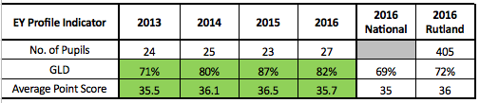
Outcomes for pupils

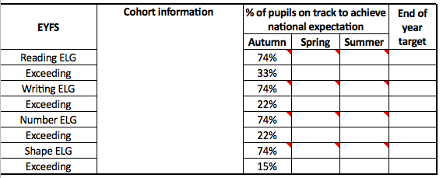

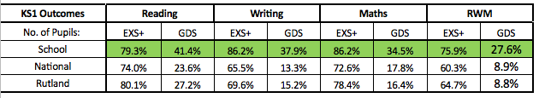

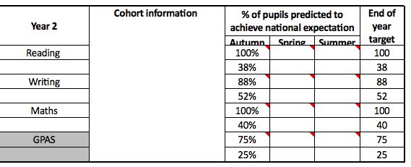

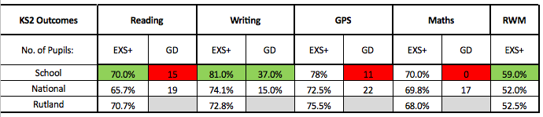

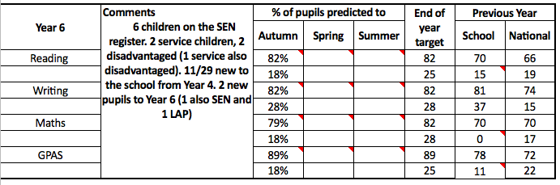

Quality of teaching and learning, curriculum and use of assessment
Good | Outstanding
- Teachers use effective planning to help pupils learn well. Time in lessons is used productively. Pupils focus well on their learning because teachers reinforce expectations for conduct and set clear tasks that challenge pupils.  - In lessons, teachers develop, consolidate and deepen pupils’ knowledge, understanding and skills. They give sufficient time for pupils to review what they are learning and to develop further. Teachers identify and support effectively those pupils who start to fall behind and intervene quickly to help them to improve their learning.  - Teachers use their secure subject knowledge to plan learning that sustains pupils’ interest and challenges their thinking. They use questioning skilfully to probe pupils’ responses and they reshape tasks and explanations so that pupils better understand new concepts. Teachers tackle misconceptions and build on pupils’ strengths.  - Pupils use feedback well and they know what they need to do to improve.  - Teachers develop pupils’ reading, writing and communication, and where appropriate mathematics, well across the curriculum.  - Teachers expect and encourage all pupils to work with positive attitudes so that they can apply themselves and make strong progress.  - Pupils develop the capacity to learn from mistakes and they become keen learners who want to find out more. Most are willing to find out new information to develop, consolidate and deepen their knowledge, understanding and skills.  - Most pupils commit to improving their work. They are given time to apply their knowledge and understanding in new ways that stretches their thinking in a wide range of subjects, and to practise key skills.  - The school gives parents information about how well their child is progressing, how well their child is doing in relation to the standards expected, and what their child needs to do to improve. | - Teachers demonstrate deep knowledge and understanding of the subjects they teach. They use questioning highly effectively and demonstrate understanding of the ways pupils think about subject content. They identify pupils’ common misconceptions and act to ensure they are corrected. MATHS  - Teachers plan lessons very effectively, making maximum use of lesson time and coordinating lesson resources well. MATHS  - Teachers provide adequate time for practice to embed the pupils’ knowledge, understanding and skills securely. They introduce subject content progressively and constantly demand more of pupils. Teachers identify and support any pupil who is falling behind, and enable almost all to catch up. MATHS  - Teachers check pupils’ understanding systematically and effectively in lessons. Teachers provide pupils with incisive feedback. Pupils are eager to know how to improve their learning.  - Teachers embed reading, writing and communication and, where appropriate, mathematics exceptionally well across the curriculum, equipping all pupils with the necessary skills to make progress.  - Teachers have consistently high expectations of all pupils’ attitudes to learning.  - Pupils love the challenge of learning and are resilient to failure. They are curious, interested learners who seek out and use new information to develop, consolidate and deepen their knowledge, understanding and skills.  - Parents are provided with clear and timely information on how well their child is progressing and how well their child is doing in relation to the standards expected. Parents are given guidance about how to support their child to improve.
Review Day
Enquiry questions:
Literacy
- Why are our reading achievements low compared to previous years? Is this a developing trend?
- Why are disadvantaged pupils attaining and achieving lower than all pupils?
- What is the impact of our new timetable changes on spelling, reading comprehension and the curriculum?
- What has been the impact of our teacher day?
Maths
- Why is our maths achievement low compared to other subject areas? Is this a developing trend?
- What is the impact of our responsive intervention sessions?
- Has the new timetable changes been implemented effectively? What is the impact of this change?
- Why didn’t any of our pupils attain a high score (greater depth) in mathematics?
- What impact has the new approach to planning and the introduction of the new progression line had on pupil progress?

Summary of Key Outcomes Lesson observations
The following discussion notes are based on previously outstanding and securely good teaching of mathematics in school (INSTEAD Nov 2016) and should to be used to stimulate debate and discussions around possible reasons for underperformance in maths across KS2. It is not an overall evaluation of teaching and learning in maths as it is too early to fully ascertain the impact of initiatives that have been recently introduced – it is the intention that the monitoring day should be as a precursor or catalyst to inform a more detailed Research and Development Programme. The process undertaken is centred around an improvement strategy – not a prove it type strategy.

Staff are teaching for mastery and greater depth. However, lesson observations and initial work samples demonstrate that there is not a collective understanding of what this means in maths. Lessons can sometimes appear disjointed and over complicated with a lack of clarity over key learning intentions or success criteria or linked independent activities.
Teachers are beginning to plan in learning journeys – lesson design must now be revisited to address any emerging misconceptions e.g. some teachers understand that fluency, reasoning and problem solving activities should be embedded throughout the teaching sequence and each lesson whilst others do not share this understanding. The vision that carefully crafted lesson design provides a step-by-step, conceptual journey through the mathematics, engaging pupils in reasoning and the development of mathematical thinking throughout is therefore underdeveloped.

Precise questioning during lessons does not always ensure that pupils develop fluent technical proficiency and think deeply about the underpinning mathematical concepts. There are too many missed opportunities of reframing questions to encourage more thought provoking – deeper responses.

Teachers are avoiding mechanical repetition – fluency and variation is evident in books. Challenge is provided by going deeper rather than accelerating into new mathematical content in all classes. At the moment, children work together on the same key point, whilst at the same time being challenged and supported to gain a greater depth of understanding and proficiency. This is still very much in the development stage for teachers and needs to be developed and monitored systematically by the maths team. Concrete and pictorial representations are not always chosen carefully enough to help build procedural and conceptual knowledge together.
The 6 Rs are embedded in all aspects of school life and is a significant strength of the team. Their learning behaviours are very well developed resulting in confident, articulate pupils who are always willing to share their eloquent ideas and thoughts. The children’s growth mind-set is very well developed in each class and something that the school should be proud of. Children understand that making mistakes is valued and that collaboration and independence is prized alongside the 6Rs of resilience, resourcefulness, respect, readiness, responsibility, reflection.

However, there are fewer examples of this being championed to the same extent in maths lessons where collaborative working seemed restricted too frequently to ‘talk partners’. Too much scaffolding and layering of support is inhibiting independence – although this is something that would require further investigating by the school. Mixed seating arrangements were evident though often children worked quite independently. This might also be a possible reason for several children ‘liking’ but not ‘loving’ maths. Do children have opportunities to enjoy the learning struggle or explore possibilities with others prior to support being offered? Children are able to follow instructions – procedures to get to the answer, often presented as process success criteria. Is this a reason for underachievement in test situations where this support is not available to the same extent when wording of problems is different or contexts are changed?

One insightful pupil stated that she would prefer less teaching and more learning.
Do the children have sufficient opportunities to engage in collaborative, exploration and investigation of maths prior to being shown the most efficient method or approach? Are we using problems, models or images to really bring maths to life with real life scenarios and opportunities to discuss the big picture to enable children to make connections between aspects of learning? Possible solutions, rather than just the right answer, are not always shared, analysed and discussed to deepen understanding. Too many children still believe that there is a right and wrong answer – and this is perpetuated, but not intentionally, by staff. Where lesson planning evidenced a problem solving approach with a focus on conceptual understanding moving into procedural teaching, the lesson moved too quickly resulting in little progress for some children who struggled to work independently on procedures as they did not yet have the conceptual understanding of the subject. Collaboration is key with teacher as facilitator and challenger.

Pupils’ difficulties and misconceptions are identified through immediate formative assessment and addressed with rapid, responsive intervention. Assessment has always been a significant strength of the school and continues to be.
Next steps
Key Actions (What) Personnel (Who) Timescale (When)
- Research and Development Project in collaboration with the LA, Diocese, Maths Hub and Rutland Teaching School Alliance. Raising achievement in maths across KS2.
- Further Internal and external moderation reports: Reliability and validity of judgements. EYFS Baseline and checkpoints, Y2 and Y6.
- Visits to settings with similar demographics – schools with high maths achievement/ progress measures across KS2
- Cross Academy projects for our M/HAPs focus on developing Mastery and Deep learning: fluency, reasoning and problem solving – application of new skills and knowledge.
- Review progress towards targets – identifying pupils at risk of not achieving their individual learning targets or expected standard, modifying and adapting practice accordingly.

Personal development, behaviour and welfare
Good | Outstanding
- Pupils are confident and self-assured. They take pride in their work, their school and their appearance.  - Pupils’ attitudes to all aspects of their learning are consistently positive. These positive attitudes have a good impact on the progress they make.  - Pupils show respect for others’ ideas and views.  - Pupils are punctual and prepared for lessons. They bring the right equipment and are ready to learn.  - Pupils value their education. Few are absent or persistently absent. No groups of pupils are disadvantaged by low attendance. The attendance of pupils who have previously had exceptionally high rates of absence is showing marked and sustained improvement.  - Pupils conduct themselves well throughout the day, including at lunchtimes.  - The school is an orderly environment. Pupils respond quickly to instructions and requests from staff, allowing lessons to flow smoothly and without interruption. Low-level disruption is rare.  - Pupils’ good conduct reflects the school’s efforts to promote high standards. There are marked improvements in behaviour for individuals or groups with particular behavioural needs.  - Parents, staff and pupils have no well-founded concerns about personal development, behaviour and welfare.  - Teachers and other adults are quick to tackle the rare use of derogatory or aggressive language and always challenge stereotyping.  - Teachers and other adults promote clear messages about the impact of bullying and prejudiced behaviour on pupils’ well-being. Pupils work well with the school to tackle and prevent the rare occurrences of bullying.  - The school’s open culture promotes all aspects of pupils’ welfare. Pupils are safe and feel safe. They have opportunities to learn how to keep themselves safe. They enjoy learning about how to stay healthy and about emotional and mental health, safe and positive relationships and how to prevent misuse of technology.  - Pupils’ spiritual, moral, social and cultural development ensures that they are prepared to be reflective about and responsible for their actions as good citizens. | - Pupils are confident, self-assured learners. Their excellent attitudes to learning have a strong, positive impact on their progress. They are proud of their achievements and of their school.  - Pupils discuss and debate issues in a considered way, showing respect for others’ ideas and points of view.  - Pupils value their education and rarely miss a day at school. No groups of pupils are disadvantaged by low attendance.  - Pupils’ impeccable conduct reflects the school’s effective strategies to promote high standards of behaviour. Pupils are self-disciplined. Incidences of low-level disruption are extremely rare.  - For individuals or groups with particular needs, there is sustained improvement in pupils’ behaviour. Where standards of behaviour were already excellent, they have been maintained.  - Staff and pupils deal effectively with the very rare instances of bullying behaviour and/or use of derogatory or aggressive language.  - The school’s open culture actively promotes all aspects of pupils’ welfare. Pupils are safe and feel safe at all times. They understand how to keep themselves and others safe in different situations and settings. They trust leaders to take rapid and appropriate action to resolve any concerns they have.  - Pupils can explain accurately and confidently how to keep themselves healthy. They make informed choices about healthy eating, fitness and their emotional and mental well-being. They have an age-appropriate understanding of healthy relationships and are confident in staying safe from abuse and exploitation.  - Pupils have an excellent understanding of how to stay safe online, the dangers of inappropriate use of mobile technology and social networking sites.  - Pupils’ spiritual, moral, social and cultural development equips them to be thoughtful, caring and active citizens in school and in wider society.

 | Attendance | Persistent Absence
All pupils  193 pupils | 97.3% | 4.7% (excl disadvantaged)  6.2% (incl disadvantaged)
Disadvantaged  16 pupils | 97% | 18.7%  (a family of 3 children)

Effectiveness of Leadership and Management
Good | Outstanding
- Leaders set high expectations of pupils and staff. They lead by example to create a culture of respect and tolerance. The positive relationships between leaders, staff and pupils support the progress of all pupils at the school.  - Leaders and governors are ambitious for all pupils and promote improvement effectively. The school’s actions secure improvement in disadvantaged pupils’ progress, which is rising, including in English and mathematics.  - Leaders and governors have an accurate and comprehensive understanding of the quality of education at the school. This helps them plan, monitor and refine actions to improve all key aspects of the school’s work.  - Leaders and governors use performance management effectively to improve teaching. They use accurate monitoring to identify and spread good practice across the school.  - Teachers value the continuing professional development provided by the school. It is having a positive impact on their teaching and pupils’ learning. Teaching is consistently strong across the school or where it is not, it is improving rapidly.  - Governors hold senior leaders stringently to account for all aspects of the school’s performance, including the use of pupil premium and SEN funding, ensuring that the skilful deployment of staff and resources delivers good or improving outcomes for pupils.  - The broad and balanced curriculum provides a wide range of opportunities for pupils to learn. The curriculum also contributes well to pupils’ behaviour and welfare, including their physical, mental and personal well-being, safety and spiritual, moral, social and cultural development.  - Leaders consistently promote fundamental British values and pupils’ spiritual, moral, social and cultural development.  - Leaders promote equality of opportunity and diversity, resulting in a positive school culture.  - Safeguarding is effective. | - Leaders and governors have created a culture that enables pupils and staff to excel. They are committed unwaveringly to setting high expectations for the conduct of pupils and staff. Relationships between staff and pupils are exemplary.  - Leaders and governors focus on consistently improving outcomes for all pupils, but especially for disadvantaged pupils. They are uncompromising in their ambition.  - The school’s actions have secured substantial improvement in progress for disadvantaged pupils.  - Governors systematically challenge senior leaders so that the effective deployment of staff and resources, including the pupil premium and SEN funding, secures excellent outcomes for pupils. Governors do not shy away from challenging leaders about variations in outcomes for pupil groups, especially between disadvantaged and other pupils.  - Leaders and governors have a deep, accurate understanding of the school’s effectiveness informed by the views of pupils, parents and staff. They use this to keep the school improving by focusing on the impact of their actions in key areas.  - Leaders and governors use incisive performance management that leads to professional development that encourages, challenges and supports teachers’ improvement. Teaching is highly effective across the school.  - Staff reflect on and debate the way they teach. They feel deeply involved in their own professional development. Leaders have created a climate in which teachers are motivated and trusted to take risks and innovate in ways that are right for their pupils.  - The broad and balanced curriculum inspires pupils to learn. Pupils’ spiritual, moral, social and cultural development and, within this, the promotion of fundamental British values, are at the heart of the school’s work.  - Leaders, staff and pupils do not tolerate prejudiced behaviour.  - Safeguarding is highly effective.
Assessment changes:
Class PaAGs: amendments have been made to Writing at KS1. It was felt by some KS1 teachers (Y1) that some objectives needed breaking down/splitting into specific year groups further. This has been done with all current KS1 class PaAGs and the master class PaAG ready for the new academic year, across all trust schools.

Management PaAG: each class has its own management PaAG. Each PaAG has been populated with data from class PaAGs. The data has then been managed so that it reflects progression in children’s depth of learning rather than coverage/breadth (see RLT data analysis document). Comments have also been placed in to show the percentage of objectives taught up to the end of Autumn assessment point. End of KS1 ‘levels’ have been added to a new column and, in Y6, a prediction of what each child should achieve as a standardised score has also been added so that some progress check can be made against this.

TestBase: new sets of optional Y3-5 tests have been ordered with online access to all data analysis tools. These papers will be delivered at the beginning of the Summer term. The online facility has been populated with the current cohorts’ details ready for data input towards the end of T5.
Early Year Foundation Stage
Good | Outstanding
- Children make at least typical progress and most children make good progress from their starting points. This includes disabled children, those who have special educational needs, those for whom the school receives additional funding and the most able, who make good progress relative to their starting points. They develop the key skills needed to make a good start in the next stage of their education.  - Children who join the school at a level below what is typical for their age, but not significantly so, catch up quickly. Any gaps between the attainment of groups, including those for whom the school receives additional funding, and all children nationally are closing.  - The educational programmes have depth and breadth across the seven areas of learning. They provide interesting and demanding experiences that meet the needs of all children.  - The quality of teaching is consistently good.  - All teachers and other adults have high expectations of children based on accurate assessment of children’s skills, knowledge and understanding when they join the school. Learning opportunities are well planned and based on regular and accurate assessments of children’s achievement so that every child is suitably challenged.  - Parents and carers contribute to initial assessments of children’s starting points when they join the school and they are kept well informed about their children’s progress. Parents are encouraged to support and share information about their children’s learning and development at home.  - Children are motivated and interested in a broad range of activities and are keen learners who regularly display the characteristics of effective learning. They listen carefully to adults and each other.  - Children’s good behaviour shows that they feel safe. They gain an understanding of risk through activities that encourage them to explore their environment. Children are learning to respect and celebrate each other’s differences and to build their understanding of diversity beyond their immediate experience.  - Safeguarding and child protection policies and procedures are implemented consistently; practice is reviewed regularly and clearly evaluated.  - Leaders and managers have an accurate understanding of the strengths and weaknesses of the provision through effective self-evaluation. They take concerted action to improve provision and can demonstrate the impact of such action, including the training and development of staff, on children’s achievement over time.  - Monitoring ensures that individual children or groups of children with identified needs are targeted, and appropriate interventions are secured so that children receive the support they need, including through effective partnerships with external | - Children make consistently high rates of progress in relation to their starting points and are extremely well prepared academically, socially and emotionally for the next stage of their education. As a result, almost all pupils in the early years provision, including disabled children, those who have special educational needs, those for whom the school receives additional funding and the most able, are making sustained progress that leads to outstanding achievement.  - Gaps between the attainment of groups of children and all children nationally, including those for whom the school receives additional funding, have closed or are closing rapidly. Any gaps between areas of learning are closing.  - A highly stimulating environment and exceptional organisation of the educational programmes reflects rich, varied and imaginative experiences that meet the needs of all children exceedingly well.  - The quality of teaching over time is outstanding and never less than consistently good; it is highly responsive to children’s needs.  - Accurate assessment, including through high quality observations is rigorous, sharply focused and includes all those involved in the child’s learning and development. Provision across all areas of learning is well planned and based on regular and precise assessments of children’s achievement so that every child undertakes highly challenging activities.  - Children are highly motivated, very eager to join in and consistently demonstrate the characteristics of effective learning with high levels of curiosity, imagination and concentration. They listen intently and are highly responsive to adults and each other. They do not distract others or become distracted themselves.  - All children are developing a very good understanding of how to keep themselves safe and manage risks and challenges. They demonstrate exceptionally positive behaviour and high levels of self-control, cooperation and respect for others.  - Children’s health, safety and well-being are significantly enhanced by the vigilant and highly consistent implementation of robust policies, procedures and practice.  - Highly successful strategies engage parents and carers, including those from different groups, in their children’s learning in school and at home.  - The pursuit of excellence by leaders and managers is demonstrated by an uncompromising, highly successful and well-documented drive to improve achievement, or maintain the highest levels of achievement, for all children over a sustained period of time. The training and development of staff is highly focused and has a significant impact on improving outcomes for children.
EYFS
The children are well settled into their first year of school life.
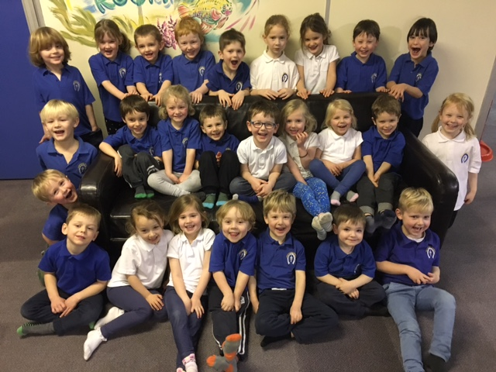
The group has come together and relationships improved due to targeted support for PSE within the first two terms. Our outdoor area evolves constantly to support the needs of each different cohort and we have found that large construction has played a big part in team cohesion, an area identified for development following baseline. We have also supported the children with language and communication, an area which is becoming an ongoing trend of development both at this school and nationally when children arrive for their first year.
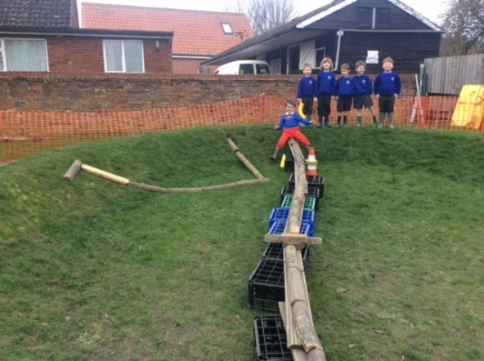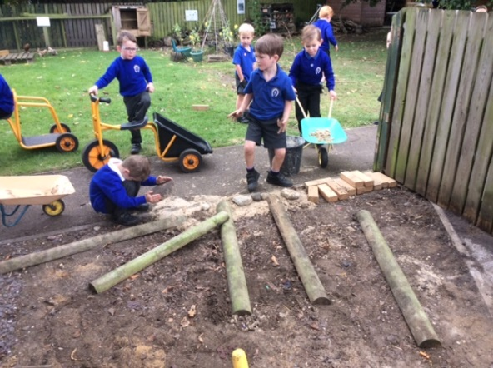
Our huge focus on fine motor control (an area which is also becoming a trend for development when children arrive at this school) is paying off and our reading/writing intervention is as follows (a table taken from weekly planning that is ever changing):
Letter formation 1 | Sounds 1 / blending | Name 1
E, A, H, T, L, O, W, E, F, | E (15) L (26) W (28) H (18) | A, E, E, F, O, T
RWI 1 ditties | RWI 3 ditties | Name 2
T, T, A, T, | E, F | A, F, H, I, J, O, P,
RWI 2 ditties | CVC words | Fine Motor
P, O, I | F, O, E, T, | A, E, E, F, H, L, O, T, W
Green group 1 ER | Letter formation 2 | Pencil grip /
H, H, E, A, E, J, H, | A, H, W, J, B | A, E, E, E, H, H, O, T, T, W
Green group 2 SC | Ginger | EE Focus
B, W, A, O, J, J | E, H, E, L | A, A, A, E, B, F, H, I, O, P, T, W, W
RWI Fred time TC/GP | Number formation | Number
T, T, A, T, P, F, E, O, E, L, I, W, H | H, H, F, E, B, A, O, W, A, F, P, E, T, O | I, E, E, A, E, T
Our current dinosaur topic has been an excellent vehicle for shape, space and measure and we continue to take every opportunity (such as taking part in the RSPB Big Bird Count) to let the children apply their ever growing knowledge of number in lots of different contexts.
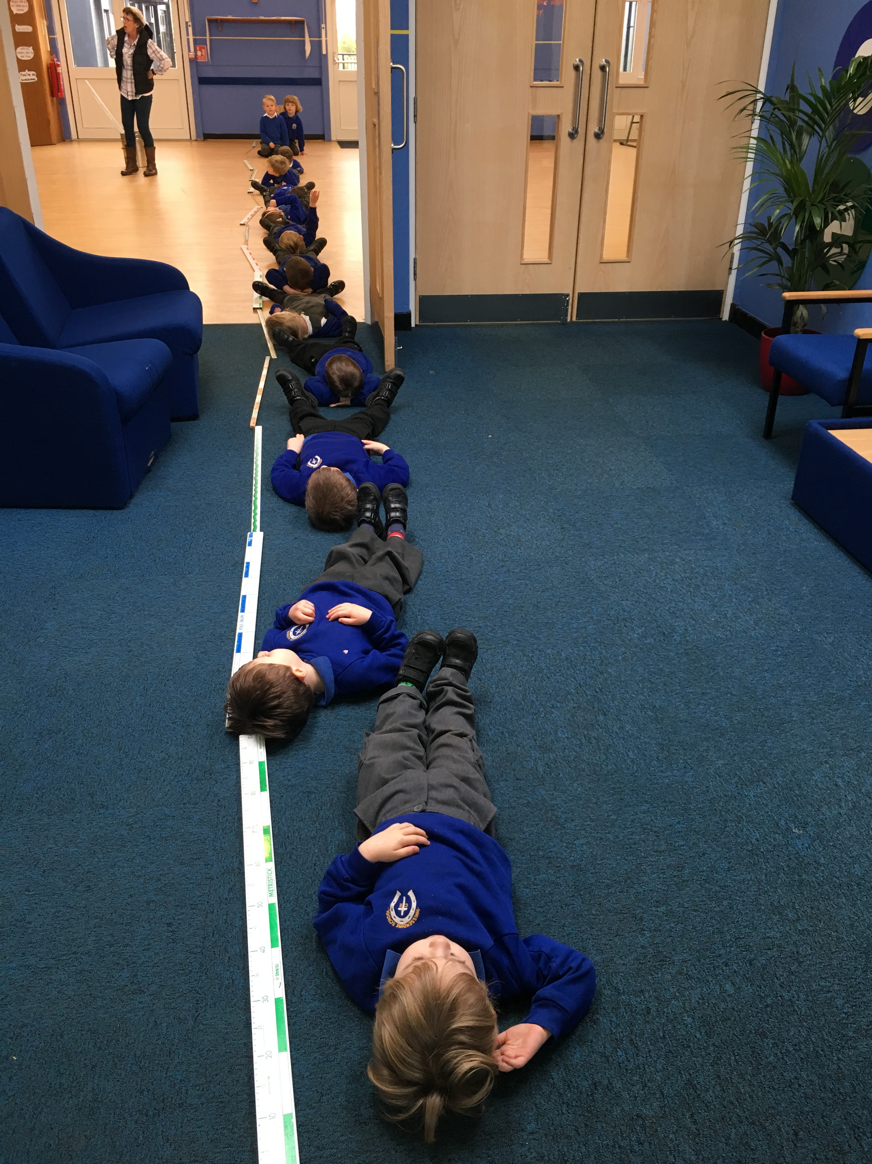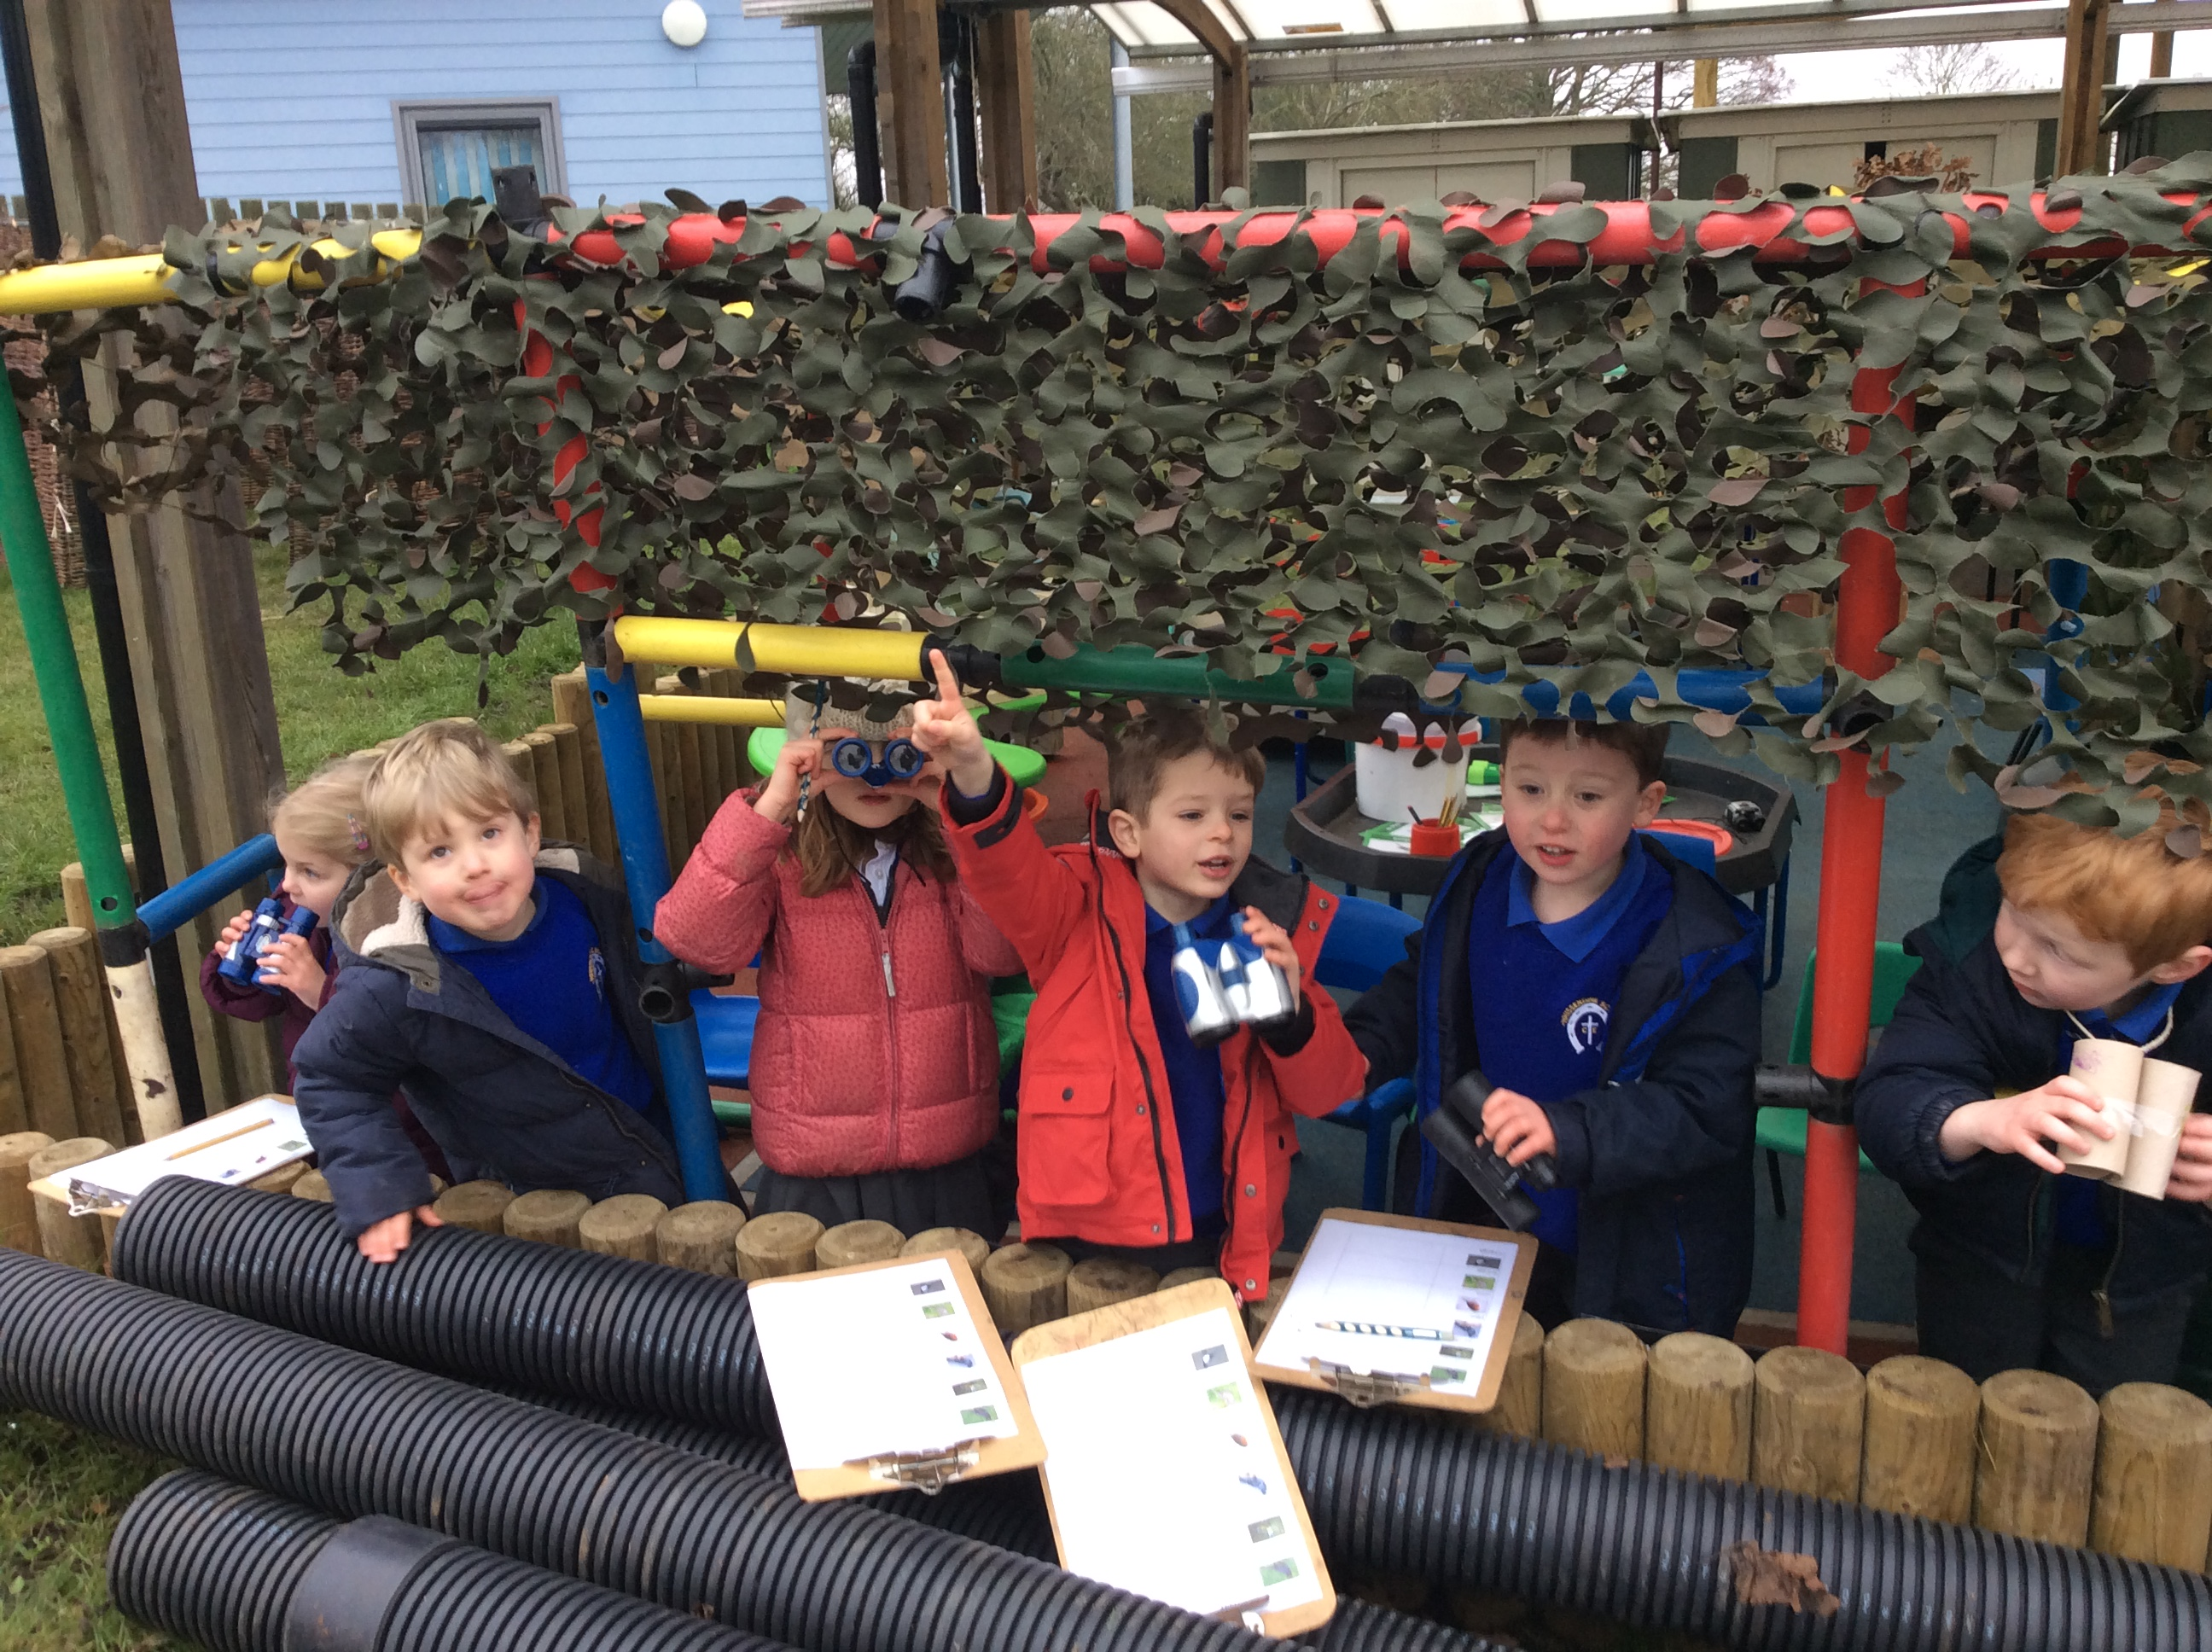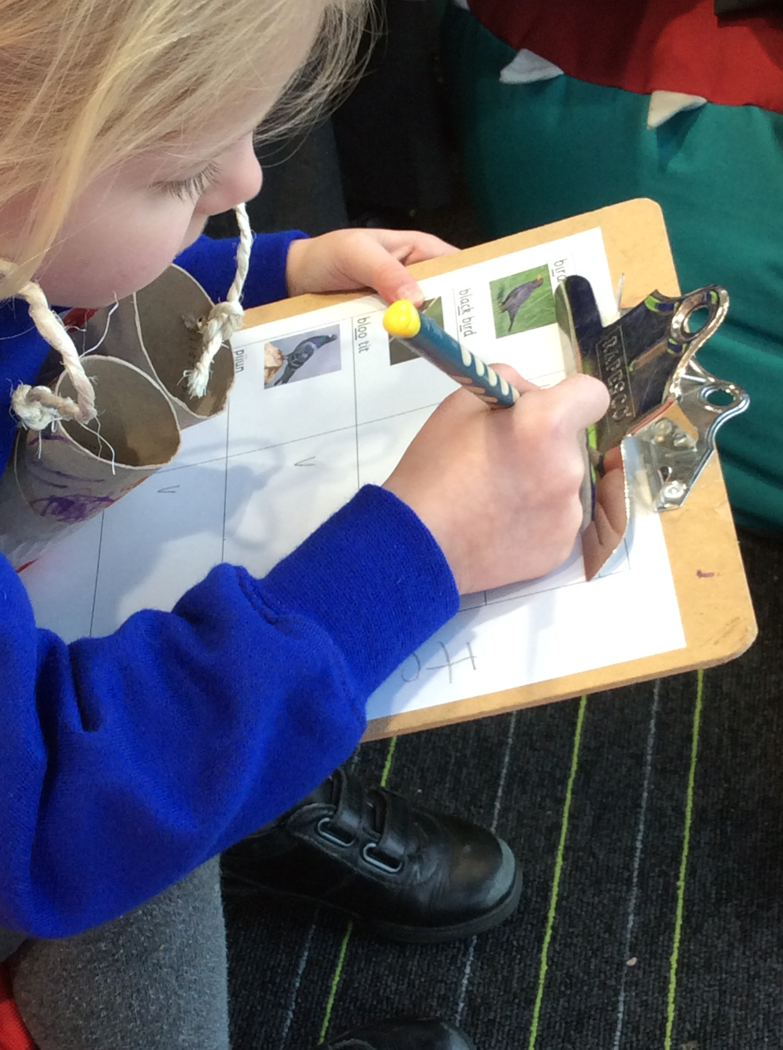
My team and I feel that the children have made tremendous progress in their first four terms and my current predictions for June when children reach the end of their foundation year are:

reading |  | writing |  | number |  | ssm
goal | 14 | goal | 16 | goal | 15 | goal | 17
exceeding | 9 | exceeding | 6 | exceeding | 6 | exceeding | 4

To get a ‘GLD’ Good Level of Development children must achieve the goal in all prime areas of learning – Personal and social, physical and language and communication together with maths (number and shape, space, measure) and literacy (reading and writing) within the specific areas of learning. Currently my predictions would be that four children will not achieve a GLD because they will not achieve the ‘goal’ in one (or more) of the areas within maths and literacy and one will not achieve the goal due to speech and language issues. Bespoke intervention is in place for these children but we must be mindful that this cohort has a large number of summer births (11) and also three children with specific special educational needs.

We have a new child joining us after Easter which also may impact on GLD scores.

At the end of Term 5 we will begin to put strategies in place to support the children on their transition into Year 1 such as lining up outside in the morning and weekly visits to Class 1 within Enrichment time (approx. 1 hour per week).

We continue to update our Early Essence assessment tool with observations of the children on a regular basis and families now have access to their own child’s learning journey and are able to upload their own photos/comments to feed into our final judgements. Our class page on the website is another tool we use to communicate with parents together with Learning Logs and our twitter feed.

School update by Senior Teacher
What’s been going on? Impact? Key achievements to celebrate

- The Literacy Team organised a Scholastic Book Fair, which raised well over £500. As a result, many new books have been purchased for our library.
- Our PA held a Christmas Fair which was a huge success - £520 was raised which has gone back into school funds.
- The children, who had attended Pablo’s Horse Sanctuary as part of their enrichment, organised a cake sale. £103 was raised.
- Ys2-6 attended the annual Pantomime, at Grantham. A great time was had by all – oh yes it was!
- Our PA funded a trip for EYFS to Cheeky Monkees in Corby.
- Ys 3 and 4 attended The Curve’s production of The Twits, which is the inspiration for their forthcoming production.
- All classes have designed their own butterflies which are now displayed as an art gallery in the ‘Cow Room’.
- The High Sheriff of Rutland visited school to lead collective worship before our Young Governors, plus a few other children, attended Peterborough Cathedral’s service celebrating Rutland and its historical background. They carried a horseshoe up the aisle during the service.
- Our KS2 Gymnastics team have won a competition, beating rivals in Leicestershire as well as Rutland.
- Our Yr 5 and 6 team won the County Road Safety competition.
- Y6 attended the annual Young Voices concert, in Birmingham. Their behaviour was exemplary and they were a real credit to the school.
- World Book Day was a huge success with recordings of audio books, Quidditch, baking of gingerbread men and lots more. To end the day, the children changed into bed clothes to listen to a bedtime story with hot chocolate or milkshake.
- Red Nose Day was celebrated with all children wearing red and staff having ‘wacky’ hair for the day.
- Ys 5 and 6 have visited London to see Andrew Lloyd Webber’s production of School of Rock The Musical.
- All teachers and teaching assistants have had Grammar training.
- Our English, Maths, IT and RE leads have attended/led network meetings for the Teaching Alliance and county.
- All teachers attended Maths training on Guided Reasoning from Transitions Education.
- Our Maths lead attended the East Midlands Maths Conference.
- Yr5 and 6 children part of the National Maths competition run by a TA.
- The school has a Facebook account for whole school news, reminders and events.

Personnel update(s):
- Caroline Handley is due to leave us at the end of Term 5 and not return. She is relocating to Manchester straight away.
- Hazel Glassford will cover Year 5 for Term 6 and Rosie Barker, our student teacher, will continue to teach Year 2.
- Mrs Victoria Edmundson has been employed as a KS2 teacher from August. She is presently in her 4th year of teaching and is maths coordinator, literacy coordinator, part of the maths hub and NQT mentor in her school in Doncaster.
- Ali Gorman has asked to not work on a Friday from next academic year: we are hoping that Sarah King will increase her teaching hours to cover this.
- Some of Ali Gorman’s SENDCO time and Claire Honorez’s French time may be shared with Exton next academic year.

Premises H&S update(s):
- Health & Safety audit was carried out by Philip Broughton from Leicestershire County Council and Paul Lucas.
- Surveys, tests and audits carried out this term: alarms tested each week, Water inspection, fire drill, Glazing survey and gym inspection.
- New building (The Barn) is completed and fully used for: small group work, whole classes in the library, interventions, guitar lessons, drum lessons, staff meetings, Early Bird club, KIA, Teaching Alliance meetings, county training and network meetings, Trust meetings, Head teacher’s meetings, children’s clubs, social care core group meetings, PPA for teachers and enrichment.
- A local community member has voluntarily paid for and carried out the works on the Barn gardens providing a huge number of plants and flowers. He also plans to turf around the building and provide a long raised bed for the children.
- An extensive snag list was produced for The Barn and Luke is working with MPH, the contractors of the Barn, to correct these issues. The negotiations with the landscaping contractors are ongoing as are the difficult negotiations with the electrical company and contractors over compensation.
- A dispute with BT is ongoing and continues to cause concern.

Accidents/near misses:
- The bench on the lazy lawn tipped backward when a lot of older children were on it. A smaller child nearly got caught by it. Actions: The bench has been moved so that it leans against the tree so it impossible to tip. Need to move to another place so it leans against a wall or fence or we secure it to the ground.

Policies to be reviewed:
- Inclusion Policy-Inclusion Governor to ratify

Trust policies
- Supporting pupils with medical conditions – Trust Policy Template
- Special leave of absence – Trust Policy Template
- Equality – Trust Policy Template
- Risk Management and Strategy – Trust Policy Template
- Whole School Risk Assessments

Charging Policy to be updated before next meeting.

